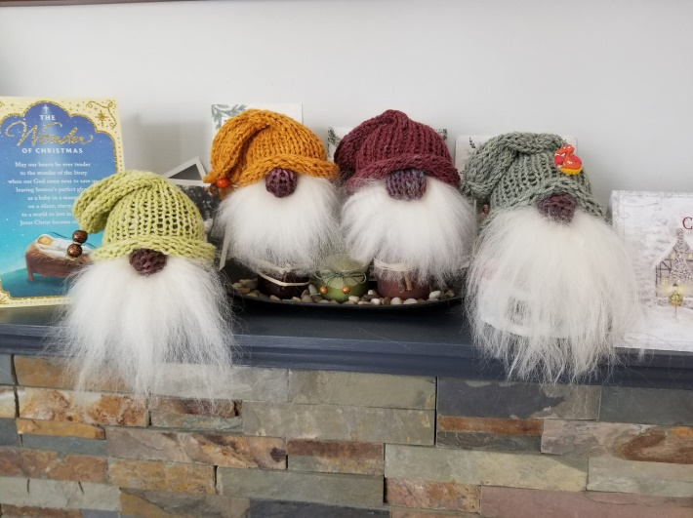
Easy Peasy Gnomes
By Lynn Snell Spinderella’s Creations ©2020
These gnomes make up very quickly and are great for gifts or to fill up your booth with low cost items, plus they make your booth look great!
I am not a pattern writer and have tried writing how I do these. I have also made them using a round knitting machine like an Addi or a Sentro, make sure they are the small machines.
Materials:
Worsted or Bulky Yarn in 2 colors
Double Point Knitting Needles to match your yarn
Natural Color Wooden Beads ( for the nose and also decorations for the hat)
Small stones, fish tank rocks, ( to weight your gnome)
Batting or roving from your animals ( to stuff your gnome)
Wool pelt scraps, long pile fake fur or white yarn for beard
Tear Mender Glue, or whatever glue you like

Body:
Cast on 22 stitches over 3 needles , using a provisional cast on.
Knit in the round for 100 rounds. Break yarn leaving a 20 inch tail. DO NOT cast off stitches. Instead, thread a yarn needle with tail yarn and run through all the live stitches on your needles.
Pull the cast on and ending edges tight , closing the tube. Fold in half. The closed tube will be the gnomes bottom, so clipping the yarn is not necessary. Put these inside the closed tube.
Put stones in the bottom of the gnome and add stuffing to make firm.
Using a basting stitch, close the folded edge of the tube and pull tight
Hat:
Using a provisional cast on 22 stitches on 3 needles and knit in the round for 35- 60 rounds. You can make the hat any length you want. Do not cast off, instead using the yarn tail and yarn needle, remove live stitches and pull all stitches tight.
The bottom of the hat should roll due to the stockinet stitches.
Place the hat on the gnome and sew a nose where you think it looks best, remembering the hat should come down covering the, would be, eyes.
If you want hair on the gnome, now if a good time to make braids and sew on the sides, or sew on long hair.
Sew the hat in place all around. I have used cute buttons at the top of the hat to help fold it over.
Using pelt scraps, fake fur or yarn, glue the beard under the nose bead.
Trim as desired Done-

